**Practical no 5**

**Aim : Implement BGP Path Manipulation & Implement BGP Communities**

1. **Implement BGP Path Manipulation**

Part 1: Build the Network and Configure Basic Device Settings and Interface

Addressing

In Part 1, you will set up the network topology and configure basic settings and interface addressing on

routers.

Step 1: Cable the network as shown in the topology.

Attach the devices as shown in the topology diagram, and cable as necessary.

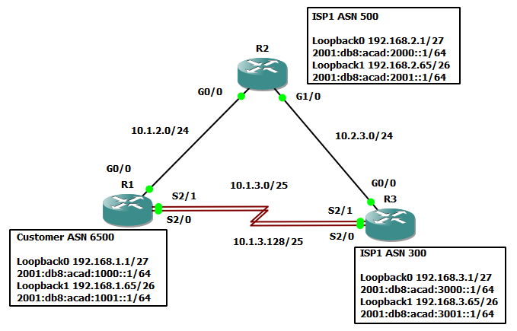

Step 2: Configure basic settings for each router.

a. Console into each router, enter global configuration mode, and apply the basic settings and interface

addressing. A command list for each router is listed below to perform initial configuration.

Router R1

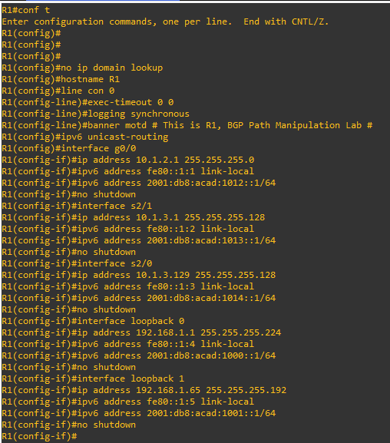

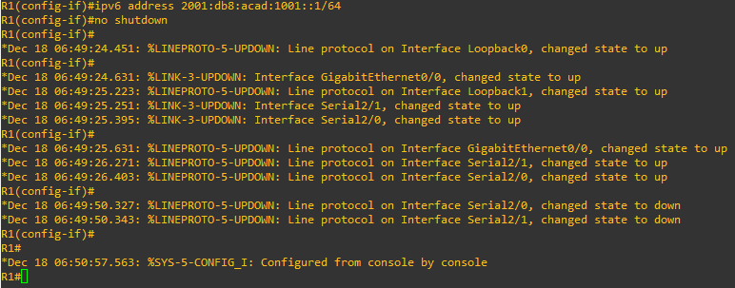

Router R2

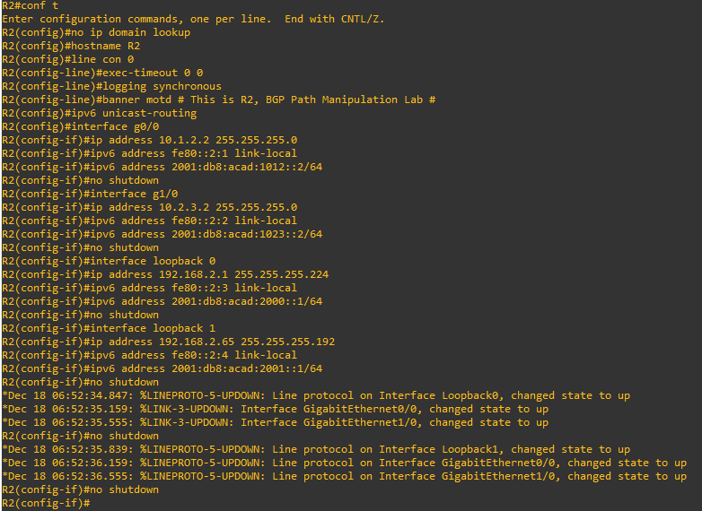

Router R3

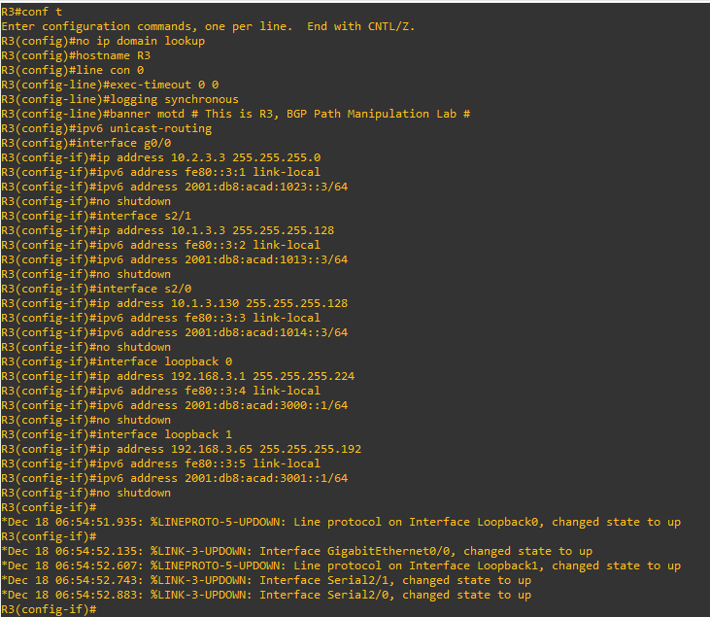

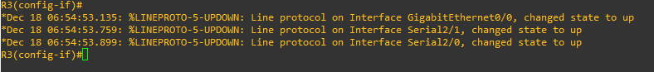

b. Set the clock on each router to UTC time.

c. Save the running configuration to startup-config.

Part 2: Configure and Verify Multi-protocol BGP on all Routers

Step 1: On R1, create the core BGP configuration.

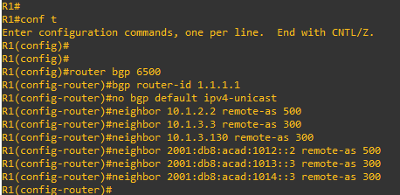

Step 2: On R1, configure the IPv4 unicast address family.

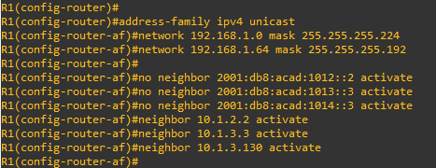

Step 3: On R1, configure the IPv6 unicast address family.

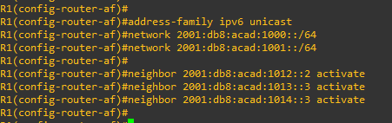

Step 4: Configure MP-BGP on R2 and R3 as you did in the previous step.

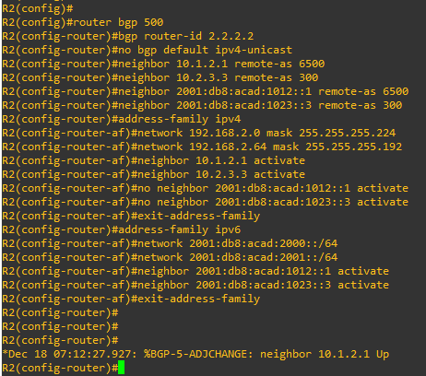

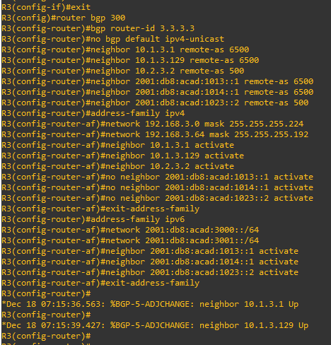

Step 5: Verify that MP-BGP is operational.

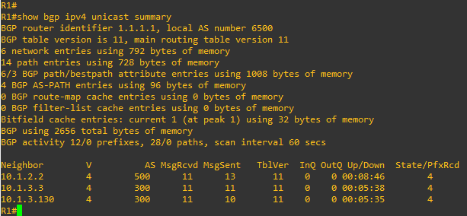

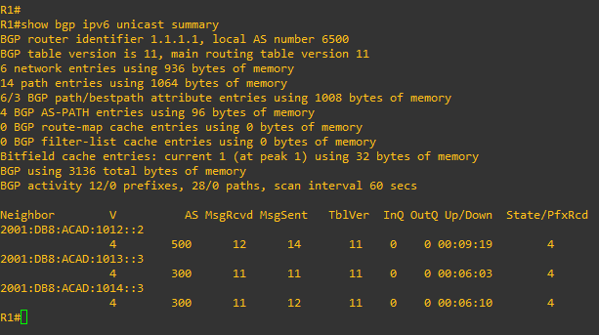

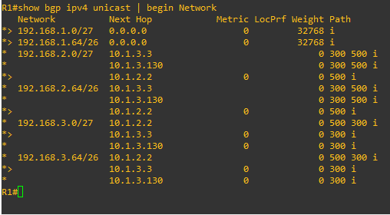

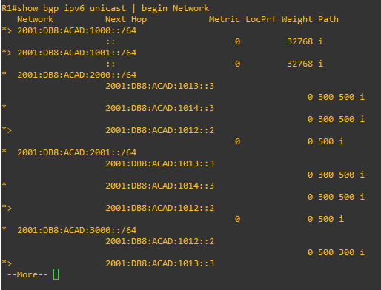

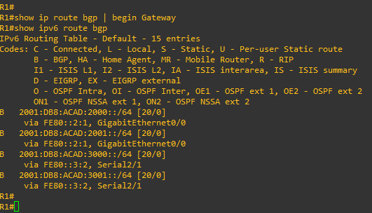

Part 3: Configure and Verify BGP Path Manipulation Settings on all Routers

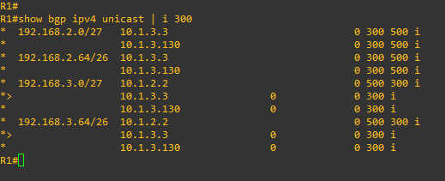

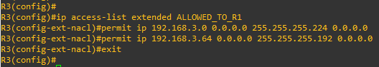

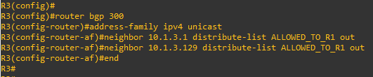



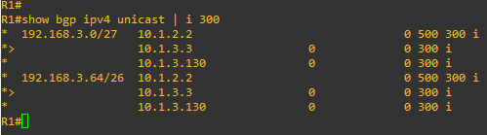

Step 2: Configure prefix-list-based route filtering.

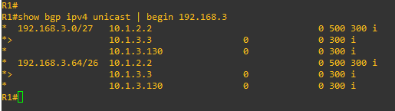

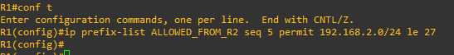

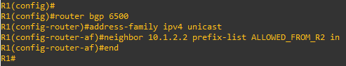

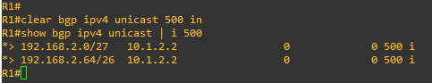

Step 3: Configure an AS-PATH ACL to filter routes being advertised.

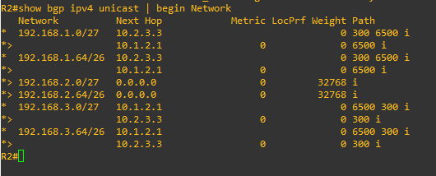

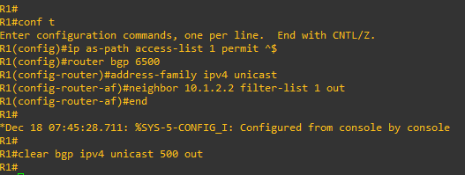

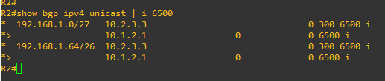

Step 4: Configure IPv6 prefix-list-based route filtering.

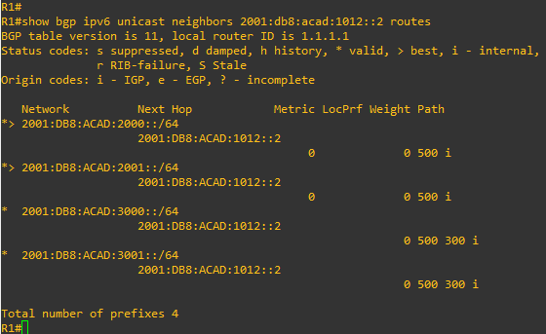

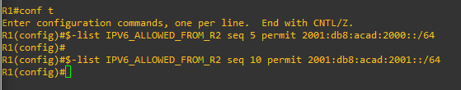

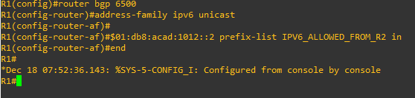

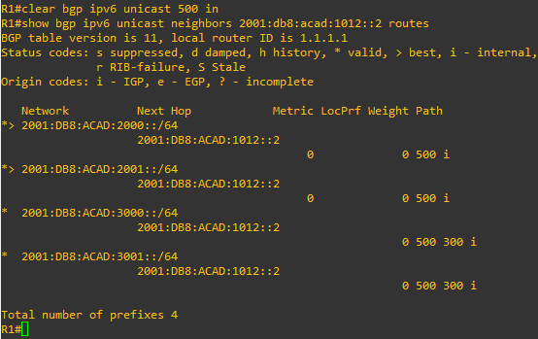

Step 5: Configure BGP path attribute manipulation to effect routing.

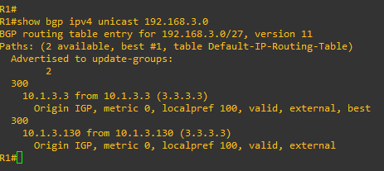

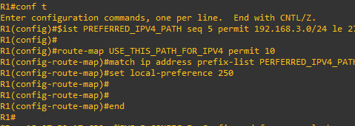

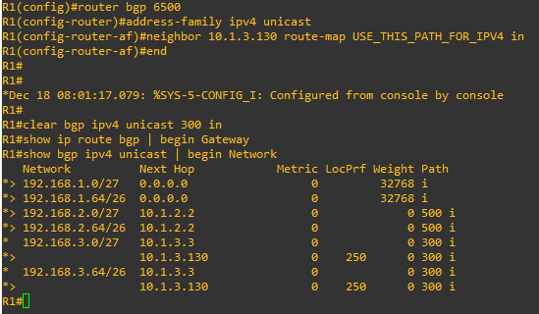

**Device Configs - Final**

**Router R1**

**R1#sh run**

Building configuration...

Current configuration : 3471 bytes

!

upgrade fpd auto

version 12.4

service timestamps debug datetime msec

service timestamps log datetime msec

no service password-encryption

!

hostname R1

!

boot-start-marker

boot-end-marker

!

logging message-counter syslog

!

no aaa new-model

ip source-route

no ip icmp rate-limit unreachable

ip cef

!

!

!

!

no ip domain lookup

ipv6 unicast-routing

ipv6 cef

!

multilink bundle-name authenticated

!

!

!

!

!

!

!

!

!

!

!

!

!

!

!

!

archive

log config

hidekeys

!

!

!

!

!

ip tcp synwait-time 5

!

!

!

!

interface Loopback0

ip address 192.168.1.1 255.255.255.224

ipv6 address FE80::1:4 link-local

ipv6 address 2001:DB8:ACAD:1000::1/64

!

interface Loopback1

ip address 192.168.1.65 255.255.255.192

ipv6 address FE80::1:5 link-local

ipv6 address 2001:DB8:ACAD:1001::1/64

!

interface Ethernet0/0

no ip address

shutdown

duplex auto

!

interface GigabitEthernet0/0

ip address 10.1.2.1 255.255.255.0

duplex full

speed 1000

media-type gbic

negotiation auto

ipv6 address FE80::1:1 link-local

ipv6 address 2001:DB8:ACAD:1012::1/64

!

interface GigabitEthernet1/0

no ip address

shutdown

negotiation auto

!

interface Serial2/0

ip address 10.1.3.129 255.255.255.128

ipv6 address FE80::1:3 link-local

ipv6 address 2001:DB8:ACAD:1014::1/64

serial restart-delay 0

!

interface Serial2/1

ip address 10.1.3.1 255.255.255.128

ipv6 address FE80::1:2 link-local

ipv6 address 2001:DB8:ACAD:1013::1/64

serial restart-delay 0

!

interface Serial2/2

no ip address

shutdown

serial restart-delay 0

!

interface Serial2/3

no ip address

shutdown

serial restart-delay 0

!

router bgp 6500

bgp router-id 1.1.1.1

no bgp default ipv4-unicast

bgp log-neighbor-changes

neighbor 10.1.2.2 remote-as 500

neighbor 10.1.3.3 remote-as 300

neighbor 10.1.3.130 remote-as 300

neighbor 2001:DB8:ACAD:1012::2 remote-as 500

neighbor 2001:DB8:ACAD:1013::3 remote-as 300

neighbor 2001:DB8:ACAD:1014::3 remote-as 300

!

address-family ipv4

neighbor 10.1.2.2 activate

neighbor 10.1.2.2 prefix-list ALLOWED_FROM_R2 in

neighbor 10.1.2.2 filter-list 1 out

neighbor 10.1.3.3 activate

neighbor 10.1.3.130 activate

neighbor 10.1.3.130 route-map USE_THIS_PATH_FOR_IPV4 in

no auto-summary

no synchronization

network 192.168.1.0 mask 255.255.255.224

network 192.168.1.64 mask 255.255.255.192

exit-address-family

!

address-family ipv6

neighbor 2001:DB8:ACAD:1012::2 activate

neighbor 2001:DB8:ACAD:1012::2 prefix-list IPV6_ALLOWED_FROM_R2 in

neighbor 2001:DB8:ACAD:1013::3 activate

neighbor 2001:DB8:ACAD:1014::3 activate

network 2001:DB8:ACAD:1000::/64

network 2001:DB8:ACAD:1001::/64

exit-address-family

!

ip forward-protocol nd

no ip http server

no ip http secure-server

!

ip as-path access-list 1 permit ^$

!

!

!

ip prefix-list ALLOWED_FROM_R2 seq 5 permit 192.168.2.0/24 le 27

!

ip prefix-list PREFERRED_IPV4_PATH seq 5 permit 192.168.3.0/24 le 27

no cdp log mismatch duplex

!

!

ipv6 prefix-list IPV6_ALLOWED_FROM_R2 seq 5 permit 2001:DB8:ACAD:2000::/64

ipv6 prefix-list IPV6_ALLOWED_FROM_R2 seq 10 permit 2001:DB8:ACAD:2001::/64

!

!

!

route-map USE_THIS_PATH_FOR_IPV4 permit 10

match ip address prefix-list PERFERRED_IPV4_PATH

set local-preference 250

!

!

!

control-plane

!

!

!

!

!

!

!

gatekeeper

shutdown

!

banner motd ^C This is R1, BGP Path Manipulation Lab ^C

!

line con 0

exec-timeout 0 0

privilege level 15

logging synchronous

stopbits 1

line aux 0

exec-timeout 0 0

privilege level 15

logging synchronous

stopbits 1

line vty 0 4

login

!

end

**Router R1**

**R2#show run**

Building configuration...

Current configuration : 2565 bytes

!

upgrade fpd auto

version 12.4

service timestamps debug datetime msec

service timestamps log datetime msec

no service password-encryption

!

hostname R2

!

boot-start-marker

boot-end-marker

!

logging message-counter syslog

!

no aaa new-model

ip source-route

no ip icmp rate-limit unreachable

ip cef

!

!

!

!

no ip domain lookup

ipv6 unicast-routing

ipv6 cef

!

multilink bundle-name authenticated

!

!

!

!

!

!

!

!

!

!

!

!

!

!

!

!

archive

log config

hidekeys

!

!

!

!

!

ip tcp synwait-time 5

!

!

!

!

interface Loopback0

ip address 192.168.2.1 255.255.255.224

ipv6 address FE80::2:3 link-local

ipv6 address 2001:DB8:ACAD:2000::1/64

!

interface Loopback1

ip address 192.168.2.65 255.255.255.192

ipv6 address FE80::2:4 link-local

ipv6 address 2001:DB8:ACAD:2001::1/64

!

interface Ethernet0/0

no ip address

shutdown

duplex auto

!

interface GigabitEthernet0/0

ip address 10.1.2.2 255.255.255.0

duplex full

speed 1000

media-type gbic

negotiation auto

ipv6 address FE80::2:1 link-local

ipv6 address 2001:DB8:ACAD:1012::2/64

!

interface GigabitEthernet1/0

ip address 10.2.3.2 255.255.255.0

negotiation auto

ipv6 address FE80::2:2 link-local

ipv6 address 2001:DB8:ACAD:1023::2/64

!

interface Serial2/0

no ip address

shutdown

serial restart-delay 0

!

interface Serial2/1

no ip address

shutdown

serial restart-delay 0

!

interface Serial2/2

no ip address

shutdown

serial restart-delay 0

!

interface Serial2/3

no ip address

shutdown

serial restart-delay 0

!

router bgp 500

bgp router-id 2.2.2.2

no bgp default ipv4-unicast

bgp log-neighbor-changes

neighbor 10.1.2.1 remote-as 6500

neighbor 10.2.3.3 remote-as 300

neighbor 2001:DB8:ACAD:1012::1 remote-as 6500

neighbor 2001:DB8:ACAD:1023::3 remote-as 300

!

address-family ipv4

neighbor 10.1.2.1 activate

neighbor 10.2.3.3 activate

no auto-summary

no synchronization

network 192.168.2.0 mask 255.255.255.224

network 192.168.2.64 mask 255.255.255.192

exit-address-family

!

address-family ipv6

neighbor 2001:DB8:ACAD:1012::1 activate

neighbor 2001:DB8:ACAD:1023::3 activate

network 2001:DB8:ACAD:2000::/64

network 2001:DB8:ACAD:2001::/64

exit-address-family

!

ip forward-protocol nd

no ip http server

no ip http secure-server

!

!

!

no cdp log mismatch duplex

!

!

!

!

!

!

control-plane

!

!

!

!

!

!

!

gatekeeper

shutdown

!

banner motd ^C This is R2, BGP Path Manipulation Lab ^C

!

line con 0

exec-timeout 0 0

privilege level 15

logging synchronous

stopbits 1

line aux 0

exec-timeout 0 0

privilege level 15

logging synchronous

stopbits 1

line vty 0 4

login

!

end

**Router R1**

R3#show run

Building configuration...

Current configuration : 3060 bytes

!

upgrade fpd auto

version 12.4

service timestamps debug datetime msec

service timestamps log datetime msec

no service password-encryption

!

hostname R3

!

boot-start-marker

boot-end-marker

!

logging message-counter syslog

!

no aaa new-model

ip source-route

no ip icmp rate-limit unreachable

ip cef

!

!

!

!

no ip domain lookup

ipv6 unicast-routing

ipv6 cef

!

multilink bundle-name authenticated

!

!

!

!

!

!

!

!

!

!

!

!

!

!

!

!

archive

log config

hidekeys

!

!

!

!

!

ip tcp synwait-time 5

!

!

!

!

interface Loopback0

ip address 192.168.3.1 255.255.255.224

ipv6 address FE80::3:4 link-local

ipv6 address 2001:DB8:ACAD:3000::1/64

!

interface Loopback1

ip address 192.168.3.65 255.255.255.192

ipv6 address FE80::3:5 link-local

ipv6 address 2001:DB8:ACAD:3001::1/64

!

interface Ethernet0/0

no ip address

shutdown

duplex auto

!

interface GigabitEthernet0/0

ip address 10.2.3.3 255.255.255.0

duplex full

speed 1000

media-type gbic

negotiation auto

ipv6 address FE80::3:1 link-local

ipv6 address 2001:DB8:ACAD:1023::3/64

!

interface GigabitEthernet1/0

no ip address

shutdown

negotiation auto

!

interface Serial2/0

ip address 10.1.3.130 255.255.255.128

ipv6 address FE80::3:3 link-local

ipv6 address 2001:DB8:ACAD:1014::3/64

serial restart-delay 0

!

interface Serial2/1

ip address 10.1.3.3 255.255.255.128

ipv6 address FE80::3:2 link-local

ipv6 address 2001:DB8:ACAD:1013::3/64

serial restart-delay 0

!

interface Serial2/2

no ip address

shutdown

serial restart-delay 0

!

interface Serial2/3

no ip address

shutdown

serial restart-delay 0

!

router bgp 300

bgp router-id 3.3.3.3

no bgp default ipv4-unicast

bgp log-neighbor-changes

neighbor 10.1.3.1 remote-as 6500

neighbor 10.1.3.129 remote-as 6500

neighbor 10.2.3.2 remote-as 500

neighbor 2001:DB8:ACAD:1013::1 remote-as 6500

neighbor 2001:DB8:ACAD:1014::1 remote-as 6500

neighbor 2001:DB8:ACAD:1023::2 remote-as 500

!

address-family ipv4

neighbor 10.1.3.1 activate

neighbor 10.1.3.1 distribute-list ALLOWED_TO_R1 out

neighbor 10.1.3.129 activate

neighbor 10.1.3.129 distribute-list ALLOWED_TO_R1 out

neighbor 10.2.3.2 activate

no auto-summary

no synchronization

network 192.168.3.0 mask 255.255.255.224

network 192.168.3.64 mask 255.255.255.192

exit-address-family

!

address-family ipv6

neighbor 2001:DB8:ACAD:1013::1 activate

neighbor 2001:DB8:ACAD:1014::1 activate

neighbor 2001:DB8:ACAD:1023::2 activate

network 2001:DB8:ACAD:3000::/64

network 2001:DB8:ACAD:3001::/64

exit-address-family

!

ip forward-protocol nd

no ip http server

no ip http secure-server

!

!

!

ip access-list extended ALLOWED_TO_R1

permit ip host 192.168.3.0 host 255.255.255.224

permit ip host 192.168.3.64 host 255.255.255.192

!

no cdp log mismatch duplex

!

!

!

!

!

!

control-plane

!

!

!

!

!

!

!

gatekeeper

shutdown

!

banner motd ^C This is R3, BGP Path Manipulation Lab ^C

!

line con 0

exec-timeout 0 0

privilege level 15

logging synchronous

stopbits 1

line aux 0

exec-timeout 0 0

privilege level 15

logging synchronous

stopbits 1

line vty 0 4

login

!

end

1. Implement BGP Communities

Part 1: Build the Network and Configure Basic Device Settings and Interface

Addressing

In Part 1, you will set up the network topology and configure basic settings and interface addressing on

routers.

Step 1: Cable the network as shown in the topology.

Attach the devices as shown in the topology diagram, and cable as necessary.



Step 2: Configure basic settings for each router.

a. Console into each router, enter global configuration mode, and apply the basic settings and interface

addressing. A command list for each router is listed below to perform initial configuration.

Router R1





Router R2



Router R3





b. Set the clock on each router to UTC time.

c. Save the running configuration to startup-config.

Part 2: Configure and Verify Multi-protocol BGP on all Routers

Step 1: On R1, create the core BGP configuration.



Step 2: On R1, configure the IPv4 unicast address family.



Step 3: On R1, configure the IPv6 unicast address family.



Step 4: Configure MP-BGP on R2 and R3 as you did in the previous step.





Step 5: Verify that MP-BGP is operational.









**Part 3: Configure and Verify BGP Communities on all Routers**

**Router R1**

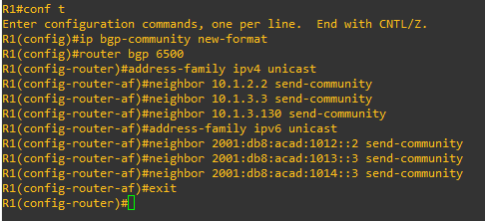

**Router R2**

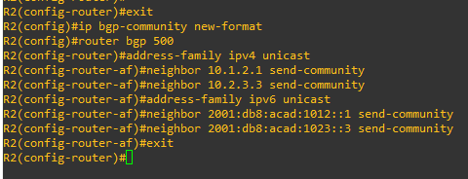

**Router R3**

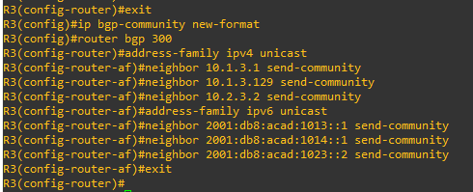

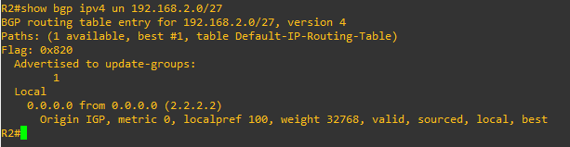

**Step 2: Configure and verify the effect of the no-export community.**

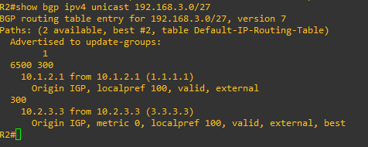

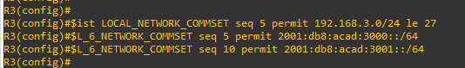

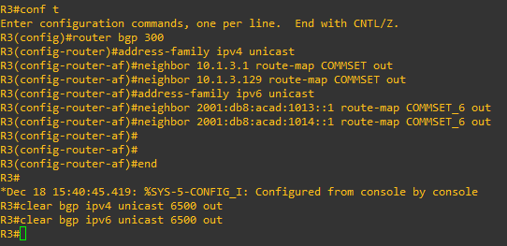

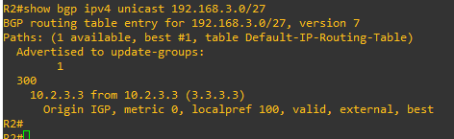

**Step 3: Add private community information to routes advertised by R1.**

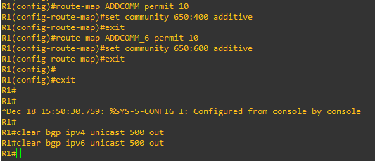

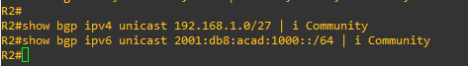

**Step 4: Configure community-based route filtering and manipulation.**

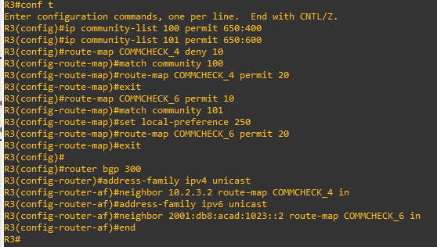

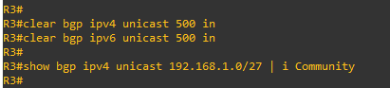

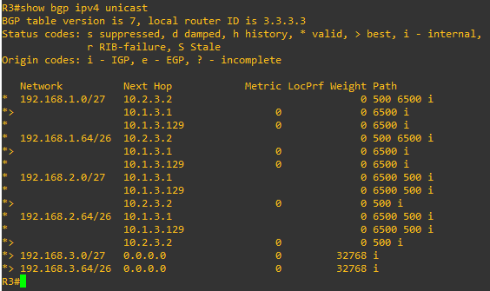

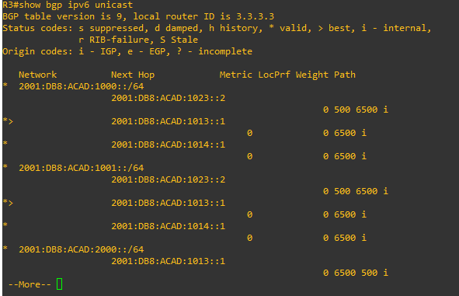

**Device Configs - Final**

**Router R2**

R1#show run

Building configuration...

Current configuration : 3213 bytes

!

upgrade fpd auto

version 12.4

service timestamps debug datetime msec

service timestamps log datetime msec

no service password-encryption

!

hostname R1

!

boot-start-marker

boot-end-marker

!

logging message-counter syslog

!

no aaa new-model

ip source-route

no ip icmp rate-limit unreachable

ip cef

!

!

!

!

no ip domain lookup

ipv6 unicast-routing

ipv6 cef

!

multilink bundle-name authenticated

!

!

!

!

!

!

!

!

!

!

!

!

!

!

!

!

archive

log config

hidekeys

!

!

!

!

!

ip tcp synwait-time 5

!

!

!

!

interface Loopback0

ip address 192.168.1.1 255.255.255.224

ipv6 address FE80::1:4 link-local

ipv6 address 2001:DB8:ACAD:1000::1/64

!

interface Loopback1

ip address 192.168.1.65 255.255.255.192

ipv6 address FE80::1:5 link-local

ipv6 address 2001:DB8:ACAD:1001::1/64

!

interface Ethernet0/0

no ip address

shutdown

duplex auto

!

interface GigabitEthernet0/0

ip address 10.1.2.1 255.255.255.0

duplex full

speed 1000

media-type gbic

negotiation auto

ipv6 address FE80::1:1 link-local

ipv6 address 2001:DB8:ACAD:1012::1/64

!

interface GigabitEthernet1/0

no ip address

shutdown

negotiation auto

!

interface Serial2/0

ip address 10.1.3.129 255.255.255.128

ipv6 address FE80::1:3 link-local

ipv6 address 2001:DB8:ACAD:1014::1/64

serial restart-delay 0

!

interface Serial2/1

ip address 10.1.3.1 255.255.255.128

ipv6 address FE80::1:2 link-local

ipv6 address 2001:DB8:ACAD:1013::1/64

serial restart-delay 0

!

interface Serial2/2

no ip address

shutdown

serial restart-delay 0

!

interface Serial2/3

no ip address

shutdown

serial restart-delay 0

!

router bgp 6500

bgp router-id 1.1.1.1

no bgp default ipv4-unicast

bgp log-neighbor-changes

neighbor 10.1.2.2 remote-as 500

neighbor 10.1.3.3 remote-as 300

neighbor 10.1.3.130 remote-as 300

neighbor 2001:DB8:ACAD:1012::2 remote-as 500

neighbor 2001:DB8:ACAD:1013::3 remote-as 300

neighbor 2001:DB8:ACAD:1014::3 remote-as 300

!

address-family ipv4

neighbor 10.1.2.2 activate

neighbor 10.1.2.2 send-community

neighbor 10.1.3.3 activate

neighbor 10.1.3.3 send-community

neighbor 10.1.3.130 activate

neighbor 10.1.3.130 send-community

no auto-summary

no synchronization

network 192.168.1.0 mask 255.255.255.224

network 192.168.1.64 mask 255.255.255.192

exit-address-family

!

address-family ipv6

neighbor 2001:DB8:ACAD:1012::2 activate

neighbor 2001:DB8:ACAD:1012::2 send-community

neighbor 2001:DB8:ACAD:1013::3 activate

neighbor 2001:DB8:ACAD:1013::3 send-community

neighbor 2001:DB8:ACAD:1014::3 activate

neighbor 2001:DB8:ACAD:1014::3 send-community

network 2001:DB8:ACAD:1000::/64

network 2001:DB8:ACAD:1001::/64

exit-address-family

!

ip forward-protocol nd

no ip http server

no ip http secure-server

!

ip bgp-community new-format

!

!

no cdp log mismatch duplex

!

!

!

!

route-map ADDCOMM_6 permit 10

set community 650:600 additive

!

route-map ADDCOMM permit 10

set community 650:400 additive

!

!

!

control-plane

!

!

!

!

!

!

!

gatekeeper

shutdown

!

banner motd ^C This is R1, BGP Path Manipulation Lab ^C

!

line con 0

exec-timeout 0 0

privilege level 15

logging synchronous

stopbits 1

line aux 0

exec-timeout 0 0

privilege level 15

logging synchronous

stopbits 1

line vty 0 4

login

!

end

**Device Configs - Final**

**Router R2**

R2#show run

Building configuration...

Current configuration : 2549 bytes

!

upgrade fpd auto

version 12.4

service timestamps debug datetime msec

service timestamps log datetime msec

no service password-encryption

!

hostname R2

!

boot-start-marker

boot-end-marker

!

logging message-counter syslog

!

no aaa new-model

ip source-route

no ip icmp rate-limit unreachable

ip cef

!

!

!

!

no ip domain lookup

ipv6 unicast-routing

ipv6 cef

!

multilink bundle-name authenticated

!

!

!

!

!

!

!

!

!

!

!

!

!

!

!

!

archive

log config

hidekeys

!

!

!

!

!

ip tcp synwait-time 5

!

!

!

!

interface Loopback0

ip address 192.168.2.1 255.255.255.224

ipv6 address FE80::2:3 link-local

ipv6 address 2001:DB8:ACAD:2000::1/64

!

interface Loopback1

ip address 192.168.2.65 255.255.255.192

ipv6 address FE80::2:4 link-local

ipv6 address 2001:DB8:ACAD:2001::1/64

!

interface Ethernet0/0

no ip address

shutdown

duplex auto

!

interface GigabitEthernet0/0

ip address 10.1.2.2 255.255.255.0

duplex full

speed 1000

media-type gbic

negotiation auto

ipv6 address FE80::2:1 link-local

ipv6 address 2001:DB8:ACAD:1012::2/64

!

interface GigabitEthernet1/0

ip address 10.2.3.2 255.255.255.0

negotiation auto

ipv6 address FE80::2:2 link-local

ipv6 address 2001:DB8:ACAD:1023::2/64

!

interface GigabitEthernet2/0

no ip address

shutdown

negotiation auto

!

router bgp 500

bgp router-id 2.2.2.2

no bgp default ipv4-unicast

bgp log-neighbor-changes

neighbor 10.1.2.1 remote-as 6500

neighbor 10.2.3.3 remote-as 300

neighbor 2001:DB8:ACAD:1012::1 remote-as 6500

neighbor 2001:DB8:ACAD:1023::3 remote-as 300

!

address-family ipv4

neighbor 10.1.2.1 activate

neighbor 10.1.2.1 send-community

neighbor 10.2.3.3 activate

neighbor 10.2.3.3 send-community

no auto-summary

no synchronization

network 192.168.2.0 mask 255.255.255.224

network 192.168.2.64 mask 255.255.255.192

exit-address-family

!

address-family ipv6

neighbor 2001:DB8:ACAD:1012::1 activate

neighbor 2001:DB8:ACAD:1012::1 send-community

neighbor 2001:DB8:ACAD:1023::3 activate

neighbor 2001:DB8:ACAD:1023::3 send-community

network 2001:DB8:ACAD:2000::/64

network 2001:DB8:ACAD:2001::/64

exit-address-family

!

ip forward-protocol nd

no ip http server

no ip http secure-server

!

ip bgp-community new-format

!

!

no cdp log mismatch duplex

!

!

!

!

!

!

control-plane

!

!

!

!

!

!

!

gatekeeper

shutdown

!

banner motd ^C This is R2, BGP Path Manipulation Lab ^C

!

line con 0

exec-timeout 0 0

privilege level 15

logging synchronous

stopbits 1

line aux 0

exec-timeout 0 0

privilege level 15

logging synchronous

stopbits 1

line vty 0 4

login

!

end

**Router R3**

R3#show run

Building configuration...

Current configuration : 3901 bytes

!

upgrade fpd auto

version 12.4

service timestamps debug datetime msec

service timestamps log datetime msec

no service password-encryption

!

hostname R3

!

boot-start-marker

boot-end-marker

!

logging message-counter syslog

!

no aaa new-model

ip source-route

no ip icmp rate-limit unreachable

ip cef

!

!

!

!

no ip domain lookup

ipv6 unicast-routing

ipv6 cef

!

multilink bundle-name authenticated

!

!

!

!

!

!

!

!

!

!

!

!

!

!

!

!

archive

log config

hidekeys

!

!

!

!

!

ip tcp synwait-time 5

!

!

!

!

interface Loopback0

ip address 192.168.3.1 255.255.255.224

ipv6 address FE80::3:4 link-local

ipv6 address 2001:DB8:ACAD:3000::1/64

!

interface Loopback1

ip address 192.168.3.65 255.255.255.192

ipv6 address FE80::3:5 link-local

ipv6 address 2001:DB8:ACAD:3001::1/64

!

interface Ethernet0/0

no ip address

shutdown

duplex auto

!

interface GigabitEthernet0/0

ip address 10.2.3.3 255.255.255.0

duplex full

speed 1000

media-type gbic

negotiation auto

ipv6 address FE80::3:1 link-local

ipv6 address 2001:DB8:ACAD:1023::3/64

!

interface GigabitEthernet1/0

no ip address

shutdown

negotiation auto

!

interface Serial2/0

ip address 10.1.3.130 255.255.255.128

ipv6 address FE80::3:3 link-local

ipv6 address 2001:DB8:ACAD:1014::3/64

serial restart-delay 0

!

interface Serial2/1

ip address 10.1.3.3 255.255.255.128

ipv6 address FE80::3:2 link-local

ipv6 address 2001:DB8:ACAD:1013::3/64

serial restart-delay 0

!

interface Serial2/2

no ip address

shutdown

serial restart-delay 0

!

interface Serial2/3

no ip address

shutdown

serial restart-delay 0

!

router bgp 300

bgp router-id 3.3.3.3

no bgp default ipv4-unicast

bgp log-neighbor-changes

neighbor 10.1.3.1 remote-as 6500

neighbor 10.1.3.129 remote-as 6500

neighbor 10.2.3.2 remote-as 500

neighbor 2001:DB8:ACAD:1013::1 remote-as 6500

neighbor 2001:DB8:ACAD:1014::1 remote-as 6500

neighbor 2001:DB8:ACAD:1023::2 remote-as 500

!

address-family ipv4

neighbor 10.1.3.1 activate

neighbor 10.1.3.1 send-community

neighbor 10.1.3.1 route-map COMMSET out

neighbor 10.1.3.129 activate

neighbor 10.1.3.129 send-community

neighbor 10.1.3.129 route-map COMMSET out

neighbor 10.2.3.2 activate

neighbor 10.2.3.2 send-community

neighbor 10.2.3.2 route-map COMMCHECK_4 in

no auto-summary

no synchronization

network 192.168.3.0 mask 255.255.255.224

network 192.168.3.64 mask 255.255.255.192

exit-address-family

!

address-family ipv6

neighbor 2001:DB8:ACAD:1013::1 activate

neighbor 2001:DB8:ACAD:1013::1 send-community

neighbor 2001:DB8:ACAD:1013::1 route-map COMMSET_6 out

neighbor 2001:DB8:ACAD:1014::1 activate

neighbor 2001:DB8:ACAD:1014::1 send-community

neighbor 2001:DB8:ACAD:1014::1 route-map COMMSET_6 out

neighbor 2001:DB8:ACAD:1023::2 activate

neighbor 2001:DB8:ACAD:1023::2 send-community

neighbor 2001:DB8:ACAD:1023::2 route-map COMMCHECK_6 in

network 2001:DB8:ACAD:3000::/64

network 2001:DB8:ACAD:3001::/64

exit-address-family

!

ip forward-protocol nd

no ip http server

no ip http secure-server

!

ip bgp-community new-format

ip community-list 100 permit 650:400

ip community-list 101 permit 650:600

!

!

!

ip prefix-list LOCAL_NETWORK_COMMSET seq 5 permit 192.168.3.0/24 le 27

no cdp log mismatch duplex

!

!

ipv6 prefix-list LOCAL_6_NETWORK_COMMSET seq 5 permit 2001:DB8:ACAD:3000::/64

ipv6 prefix-list LOCAL_6_NETWORK_COMMSET seq 10 permit 2001:DB8:ACAD:3001::/64

!

!

!

route-map COMMCHECK_4 deny 10

match community 100

!

route-map COMMCHECK_4 permit 20

!

route-map COMMCHECK_6 permit 10

match community 101

set local-preference 250

!

route-map COMMCHECK_6 permit 20

!

!

!

control-plane

!

!

!

!

!

!

!

gatekeeper

shutdown

!

banner motd ^C This is R3, BGP Path Manipulation Lab ^C

!

line con 0

exec-timeout 0 0

privilege level 15

logging synchronous

stopbits 1

line aux 0

exec-timeout 0 0

privilege level 15

logging synchronous

stopbits 1

line vty 0 4

login

!

end